Why Do Cells Divide?
- To reproduce their own kind!
- This can be a single cell or a multicellular organism.
{This is the ROLE of cell division}
Hmmm…test question?

What is the Result of Cell Division?
- Cell division results in genetically identical daughter cells.
- Two Copies of DNA and organelles are made and distributed to each daughter cell.

{Good Thing to Know!}

What is the cell cycle?
- All the activities of a cell from its parent’s division to its own division.

{Important definition?}

The Cell Cycle
INTERPHASE
Synthesis Phase (S)

INTERPHASE
INTERPHASE
First Gap Phase (G₁)

Second Gap Phase (G₂)
Mitosis Phase/Cytokinesis (M)

G₁ Phase
- Regular cell work
- Protein supply increases
- Cell grows in size

{These are the key characteristics of the G₁ Phase.}
Hmmm…test question?

S Phase

- DNA Replicates
- Two identical copies of each DNA molecule are made
{DNA REPLICATION IS THE PURPOSE OF THE SYNTHESIS PHASE.}
My that’s interesting!

G₂ PHASE
- Cell continues to grow before dividing.

{Good Thing to Know!}

INTERPHASE
- Interphase accounts for 90% of the cell cycle
- It includes the G₁, S, and G₂ Phases

{Important information?}

Mitosis
- The process a cell undergoes to divide the nucleus. The result are two new nuclei each with a set of chromosomes equal to the parent nucleus.
- Protein supply increases
- Cell grows in size

{Looks like we have an important definition here!}
Hmmm…Interesting!

Prophase
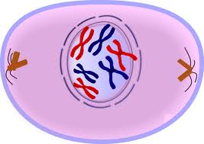
- Chromatin strands begin coiling more tightly.
- Each strand has an indentical twin called a sister chromatid.
- Identical sister chromatids join together at the centromere. These are the chromosomes.
- The mitotic spindle begins to form.

Prometaphase
- The nuclear envelope fragments.
- Microtubules extend from each centrosome to the middle of the cell.
- Some of the microtubules attach to the kinetochores of the chromosomes.

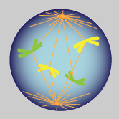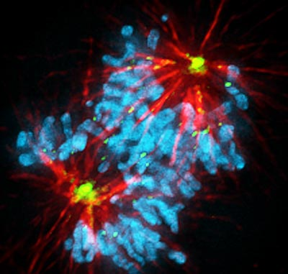

Metaphase
- The centrosomes are now at opposite ends of the cell.
- The chromosomes line up at the metaphase plate.
- Each sister chromatid has a kineticore that is attached to a microtubule coming from the centrosomes.

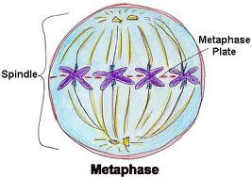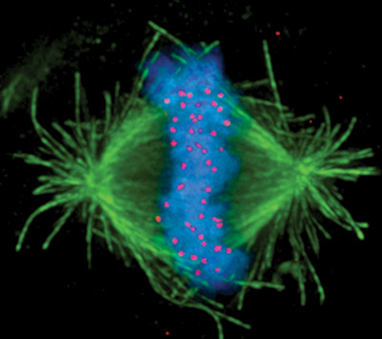

Anaphase
- The chromatids separate.
- Each of the chromosomes move towards opposite ends of the cell as the microtubules shorten.
- By the end of Anaphase, the two ends of the cell have equal and complete chromosomes.

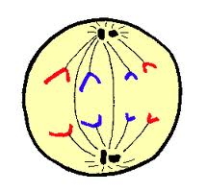

Telephase
- Two daughter nuclei begin to form in the cell.
- Each form a nuclear envelope.
- The chromosomes become less condensed.

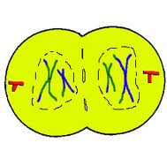

Cytokinesis
- In animal cells, cytokinesis involves the forming of a cleavage furrow.
- The cleavage furrow “pinches” the cell in two.
- The two new daughter cells are now formed and the cell cycle begins again.

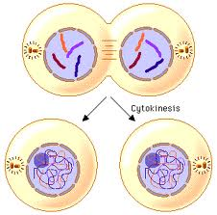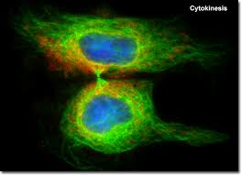

- Regular Cell Work
- Protein Supply Increases
- Cell Grows in Size
- DNA Replicates
- Cell Continues to Grow Before Dividing

